**Test Automation – Assignment-I**

**Application to be tested - URL:**

https://www.ebay.com

**Instructions:**

* Use different locators
* Include Assert statements
* If any of the steps is missing for the test scenario, you can pick alternate step/scenario from the same website and proceed with the automation
* Use Chrome Browser
* Include Time delays ( sleep/implicit/explicit) wherever needed

**Tasks:**

* Go to ebay.com

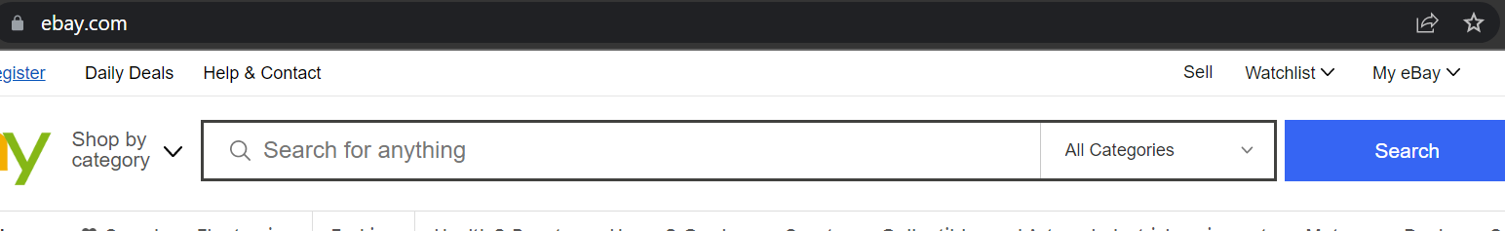

* Enter “Selenium” in searchbox

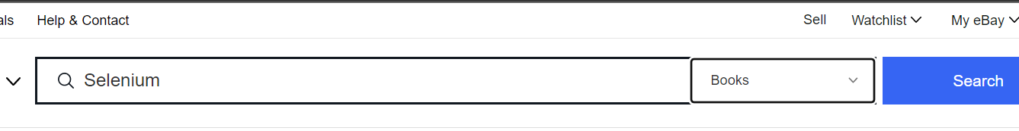

* Click Search button
* Click “Buy it now” tab

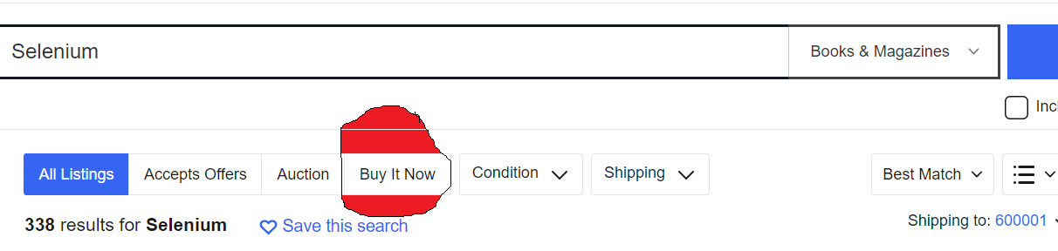

* Select “Time: newly listed”

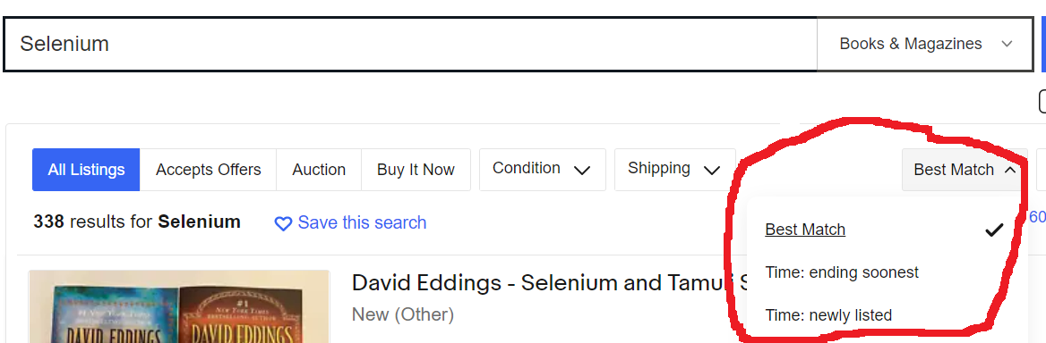

Validate if the item displayed at the top has current date with “Sep” in it.

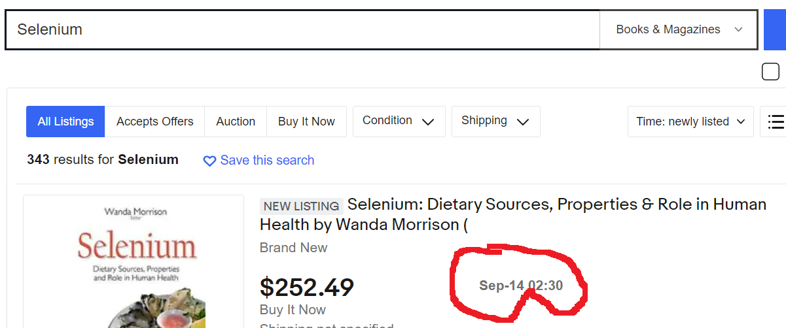

**Refer screenshot for each step**